Newham u3a
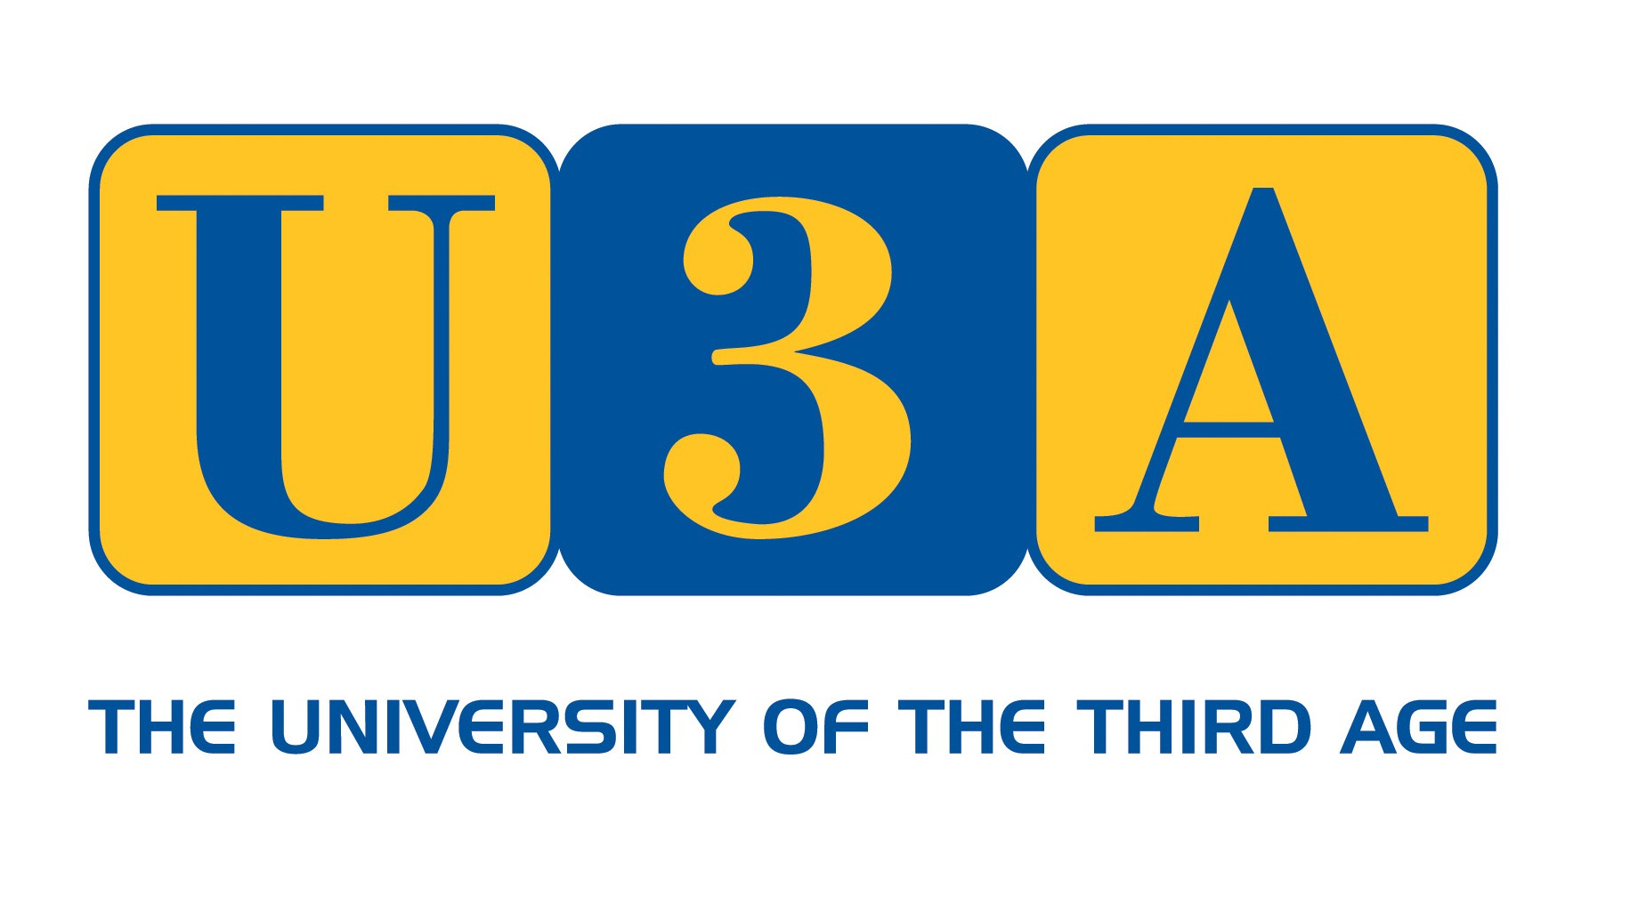

Member Application Form
Annual fee is £15 Membership year runs from November to October
(Concession £5 discount) available for anyone receiving pension credits – please provide evidence)
(£5 discount if you belong to another u3a – with valid current year membership (quote u3a & member number)
Fees include a £ 5 fee payable to the Third Age Trust (National body of u3a), which provides a range of support services and benefits, incl. liability insurance cover and the use of (Beacon) membership system to securely store membership data
Name

Address

Home phone and/or mobile phone
Personal email address

Group(s) you would like to join

Any group(s) you would like or could volunteer to run
How did you hear about us?

If you are a member of another U3A | U3a name | Members number

* our primary means of communication will be by Email, WhatsApp and / or SMS
* Newham u3a will not be using letter post (due to cost considerations)

Terms and Conditions of Membership:
All members must:
- Abide by the Principles of the u3a movement
- Always act in the best interests of the U3A and never do anything to bring the U3A into disrepute
- Abide by the terms and conditions of the constitution
- Treat fellow members with respect and courtesy at all times
- Comply with and support the decisions of the elected committee
- Advise the committee of any change in their personal details
- Abide by the Member Code of Conduct
(Documents & Policies relating to the above terms & conditions are available on the newham-u3a.org.uk website)
1/2

PRIVACY STATEMENT

Newham u3a requires members to provide their personal information so that you can be kept informed about events and activities that are offered as part of your membership. Newham u3a’s lawful basis for collecting and storing your information is legitimate interest / contract with you as a member with the u3a. In processing your informationNewham u3a will:

Store it securely
- Use it to communicate with you as a u3a member
- Share your information with group leaders/convenors for those groups that you are a member of
- Send you general information about the Third Age Trust, the national organisation to which all u3as are affiliated

Are you happy to be added to the Newham u3a list for direct mailing of the u3amatters magazines ?

(Please note u3amatters magazines are on a free trial basis until the end of March 2025. We will ask you to confirm in March 2025 - the subscription amount of £4 is payable from 1st April 2025.

Please circle either: Y or N

Please note that If you answer Y, this gives consent to your data being shared with the company which oversees the distribution of the Trust magazines.

I consent to my data being shared with the company who oversee the distribution of the Trust Magazines

Please note that you can request for your data not to be used for the direct mailing of Third Age Trust magazines at any time by contacting the secretary sec@newham-u3a.org.uk
____________________________________________________________________________

I apply for membership of Newham U3A and confirm that I will abide by the terms of membership as stated above. I confirm that I have completed the form myself – full payment is required at the time of application.
(or membership will be subject to confirmation funds received)
This form can be emailed to admin@newham-u3a.org.uk OR delivered to the group lead of the first Newham u3a session you attend.

I am paying the appropriate membership fee as noted at top of p.1 (£15/£10) of this form (delete as appropriate from following options) – additional voluntary donations are also acceptable (extra £5, £10, £15 or £20)

- By Bank Transfer to Newham U3A account: sort code 30-99-50 account no. 52035363 quoting my name in the Reference field, so Newham u3a can trace my payment in due course on its bank statements.
- Other forms of payment – by card payment (where a Newham u3a payment machine is available)
- Cheques (if no other option is available (please hand this to your Group Lead) payable to Newham U3A

Gift Aid
I am a UK tax payer and wish my membership fee to be Gift Aided. Please ✓

I understand that if at some future date I no longer pay sufficient tax and/or no longer wish to belong to the gift aid scheme I will inform the newham U3A committee.

SIGNED……………………………………………….. DATED………………………..

(Electronic Signature acceptable)

2/2

